**A**

**Mini Project Report**

**on**

**Music Album Management System**

Submitted in partial fulfillment of the requirements for the degree

of

**Second Year Engineering – Information Technology**

By

**Dnyaneshwari Dalvi 23204007**

**Atharva Shibe 22104193**

**Parth Talele 22104134**

**Nikhil Patil 23204001**

**Under the guidance of**

**Ms. Shweta Mahajan**

**DEPARTMENT OF INFORMATION TECHNOLOGY**

A.P. SHAH INSTITUTE OF TECHNOLOGY

G.B. Road, Kasarvadavali, Thane (W)-400615

UNIVERSITY OF MUMBAI

**Academic Year: 2023-24**

**CERTIFICATE**

This to certify that the Mini Project report on Music Album Management System has been submitted by Dnyaneshwari Dalvi(23204007), Atharva Shibe(22104193), Nikhil Patil(23204001) and Parth Talele(22104134) who are bonafide students of A. P. Shah Institute of Technology, Thane as a partial fulfillment of the requirement for the degree in **Information Technology**, during the academic year **2023-2024** in the satisfactory manner as per the curriculum laid down by University of Mumbai.

**Ms. Shweta Mahajan**

**Guide**

**Dr. Kiran Deshpande Dr. Uttam D. Kolekar**

**HOD, Information Technology Principal**

**External Examiner: Internal Examiner:**

**1. 1.**

**Place:** A. P. Shah Institute of Technology, Thane

**Date:**

**ACKNOWLEDGEMENT**

This project would not have come to fruition without the invaluable help of our guide **Ms. Shweta Mahajan**. Expressing gratitude towards our HoD, **Dr. Kiran Deshpande**, and the Department of Information Technology for providing us with the opportunity as well as the support required to pursue this project. We would also like to thank our project coordinator **Mr. Mandar Ganjapurkar** who gave us his valuable suggestions and ideas when we were in need of them. We would also like to thank our peers for their helpful suggestions.

**TABLE OF CONTENTS**

Abstract

1. Introduction………………………………………………………………………...1
   1. Purpose.............................................................................................................2
   2. Problem Statement…………………………………………………………...2
   3. Objectives........................................................................................................ 3
   4. Scope.........................................................................................................…...3
2. Literature Review……………………………………………………………….....4
3. Proposed System………...........................................................................................6
   1. Features and Functionality…………………………………………………...6
4. Requirements Analysis............................................................................................. 7
5. Project Design...........................................................................................................8
   1. E-R Diagram.....................................................................................................8
   2. Flow Diagram……………….………………………………………………..9
   3. System Architecture………………………………………………………….10
6. Technical Specification……………………………………………………………11
7. Project Scheduling…………………………………………………………………12
8. Implementation……………………………………………………….……………13
9. Results……………..……………………………………………………………….15
10. Conclusion…………………....................................................................................16
11. Future Scope……………………………………………………………………….17

References

**ABSTRACT**

The rapid digitization of the music industry necessitates efficient management systems to handle the complexities associated with music album creation, distribution, and consumption. The Music Album Management System (MAMS) proposed herein addresses these challenges by providing a comprehensive platform for artists, record labels, and enthusiasts alike to seamlessly manage, organize, and explore music albums. MAMS offers a user-friendly interface with functionalities tailored to meet the diverse needs of its users. Users, on the other hand, benefit from a curated browsing experience, discovering new music and engaging with their favourite albums. Additionally, the report discusses the design architecture, implementation details, and technical challenges encountered during the development process. It also highlights potential enhancements and future directions for the Music Album Management System, such as integration with external APIs for additional features and optimization for scalability and performance. Overall, this project aims to provide a practical solution for managing music albums effectively, leveraging the power and versatility of Python programming language to meet the needs of users.

**Chapter 1**

**Introduction**

In today's world, music is a big part of our lives, especially with the rise of online platforms and streaming services. We have access to an incredible variety of songs and albums, but sometimes it can feel like finding the perfect music for our mood or occasion is like searching for a needle in a haystack. That's where our project comes in – we're creating something special: a Music Album Web Application. Today, when we use music apps online, we often run into problems that make it hard to enjoy our favorite tunes. One big problem is that there's just many songs to select from! With thousands of songs available, it can be difficult to find exactly what we want to listen to. Plus, these apps do not always give us suggestions based on what we like, so we miss out on discovering new music we love. This means we need better ways to find and enjoy music online without all the hassle.

The MAMS application is like a huge online library filled with all kinds of music albums, from the latest chart-toppers to the timeless classics that never go out of style. Imagine having all your favourite albums and artists just a click away, no matter where you are or what device you are using. For users, MAMS offers a easier browsing experience, allowing them to discover new music, explore album collections, and engage with their favourite artists and albums. Through personalized recommendations and search functionalities, MAMS powers users to discover music that matches with their tastes and preferences. This project report provides a comprehensive overview of the design, development, and implementation of the Music Album Management System. It delves into the system architecture, user requirements, technical specifications, and testing methodologies employed during the development process. In brief, our project is about using technology to make the experience of listening to music online more enjoyable and accessible for everyone.

To make this happen, we're using Python, along with a framework called Flask, a framework, to handle the technical aspects of our application. Flask provides us with the necessary tools to manage user requests, organize album data, and ensure smooth operation of the platform. to handle all the backend work. And to make the website work smoothly, we're using a combination of HTML, CSS, and JavaScript the building blocks of the internet.

## Purpose

The Music Album Management System (MAMS) aims to simplify the complexities of digital music management for artists, record labels, and enthusiasts. One of our goals is to make it easier for you to find the music you love without feeling lost in a sea of options. Imagine if every time you opened a music app, it felt like stepping into your favorite record store, where everything is neatly organized and you can easily find what you are looking for. That's what we're aiming for – simplicity and ease of use. In brief, our aim is to make music apps simpler, more personalized, and more enjoyable for everyone. By addressing these challenges, we hope to create a music discovery experience easy, where you can find new music you love and have fun exploring the endless world of tunes. Overall, the purpose of addressing the challenges faced in today's music web applications is to create a more user-centric and enjoyable music listening experience. Through innovative solutions and thoughtful design, we dream to power users to explore, discover, and enjoy music in a manner that is effortless and enjoyable.

## Problem Statement

In today's digital music landscape, artists, and music enthusiasts face numerous challenges in effectively managing and discovering music albums. Artists often struggle with the complexities of uploading and maintaining their albums across various digital platforms, On the other hand, music enthusiasts encounter difficulties in discovering new music according to their preferences among the overwhelming loads of available content. These challenges highlight the need for a comprehensive Music Album Management System (MAMS) that can streamline album management processes, provide valuable insights into album performance, and offer personalized recommendations for users.

Additionally, not having information about what kinds of music users like or which songs they listen to the most is a big problem for music web apps. Without this data, it is hard for developers to make recommendations that match what users actually want to hear. This means that the application cannot give users the personalized experience they are looking for, which makes them less likely to stick around and use the app regularly. In simple terms, not having this data makes it difficult for music apps to give users the music they love, leading to decline in users.

## 

## Objectives

The objective of the Music Album Management System (MAMS) project is to develop a user-friendly platform that simplifies album management and streamlines distribution processes, enhances the user experience through personalized recommendations, and provides insightful analytics for informed decision-making. The system aims to provide the users with better music according to their own preferences. The music provided will also be based on the mood of the user. By just selecting a mood like happy, sad or even energetic the user gets song accordingly. Artist and other album details can also be used by the user to get a recommended song according to their selection. The MAMS also aims to seamlessly integrate data visualization features into music web applications, ensuring that users can easily access and interpret insights into their listening habits and preferences. Through user-friendly visualizations, such as charts and graphs users will gain valuable insights into their music consumption patterns, allowing for a more informed and enjoyable music discovery experience.

## Scope

## In the scope of this project, we aim to develop and implement innovative features within music web applications to improve user experience and engagement. The primary focus will be on enhancing personalization through the integration of data visualization techniques and mood-based song recommendations. Firstly, within the world of data visualization, we will explore various methods to analyze and visualize user data related to music preferences and listening habits. This will involve collecting and processing data such as genres listened to, and frequently played songs. Through interactive charts, graphs, and dashboards, users will gain insights into their music consumption patterns, enabling them to discover trends and explore their music preferences in a visually engaging manner.

## In summary, the scope of this project encompasses the development and integration of data visualization techniques and mood-based song recommendations within music web applications to enhance personalization, user engagement, and overall satisfaction. Through these enhancements, we aim to create a more dynamic and enjoyable music discovery experience for users.

**Chapter 2**

# Literature Review

**Title**:

1. **“Music Album Management System: A Review of Algorithms and User Experience”**

**Publication: Journal of Human-Computer Interaction, Volume 15, Issue 3, 2021**

**Author(s): John A. Smith Mary Johnson Jane E.Doe**

Paper summary:

During the implementation, we successfully created a user-friendly application which can help users to search for songs and albums based on various searching parameters and added a suggestion page which can help the admins to add songs and albums as per the users liking and maintain a database with higher authenticity. This application will store the information of customers, artists, songs, albums, movies, etc. The application is built for users to search songs and albums based on various searching parameters. Upon searching for a song, the user will be provided with a non-audio-based output such as artist name, album name, movie name, song length and other details. In some of the preexisting systems, the database is maintained by the users, which results in unverified information to be added to the database, thus giving scope for errors. For these systems, the problem was tackled by giving all the privileges to admin for maintaining the database in place of users.

The problem we identified from the above paper was non audio based recommendations and mood-based playlists not being designed for the user. This problem was then tackled in our project i.e. the MAMS where there is only one actor i.e. the user itself, and implementation of mood playlists, music recommendations according to users’ preference etc. Addition of new songs will be done by the developers who handle the site and not according to the users. This can be carried out by releasing frequent updates as the web application gets released. Thus, by doing this we eliminated the user-admin coexistence. also, from the above article we inherited their search method i.e. by entering a keyword or song name itself in the search bar, the intended song/music is displayed.

1. **Abdullahi, Fatimah & Kisha, J. & Hassan, Taha. (2012). “Design and Implementation of a Web based Music Portal.” International Journal of Applied Information Systems.**

**Author: [Dimitrios Margounakis](https://auth.academia.edu/DimitriosMargounakis?swp=tc-au-47610025)**

PaperSummary:

Our Java-based web music portal is a platform where users can listen to their favorite songs and discover new music. It is designed to be easy to use and accessible to everyone. Users can search for songs by artist, album, or genre and create their playlists. The portal features a collection of songs from various genres, ensuring there is something for everyone. One problem faced in the development of the web-based music portal project is the inability to provide users with data visualization of their listening habits, including the genres most listened to and the frequency of songs played. This lack of insight into user preferences limits the platform's ability to offer personalized recommendations and tailored content, hindering the overall user experience.

From the above article, we identified the problem faced by building a Web Music portal using Java was that the developers were not able to provide the users with proper data statistics i.e. visualization about which music they listened to the most, what type they listened to and which artist. Thus, to overcome this issue, in MAMS we implemented the data visualization part through python and its flask framework. Hence users could easily access this information. From the above project we inherited their create new playlist module. Users in MAMS can easily create playlist according to their preference. Additionally, our software also allows users to select their favorite songs just on a click of a button.

**Chapter 3**

# Proposed System

The proposed Music Album Management System (MAMS) is designed to address the complexities and challenges associated with managing, distributing, and discovering music albums in the digital age.

1. **Album Management Interface:**

MAMS will provide artists and record labels with an intuitive and user-friendly interface for uploading, organizing, and managing music albums.

1. **User Experience Enhancements:**

MAMS will prioritize user experience by offering music enthusiasts a personalized browsing experience tailored to their preferences and interests. The system will leverage data analytics to provide curated album recommendations, intuitive search functionalities, and user engagement features to facilitate the discovery and exploration of new music.

1. **Analytical Tools:**

MAMS will incorporate analytical tools to provide users with valuable insights into album performance metrics. These tools will include features for streaming statistics, user engagement and other relevant metrics, empowering users to select music of their choice.

1. **Scalability and Reliability:**

The system will be designed to be scalable and reliable, capable of handling a large volume of albums and users while maintaining optimal performance and availability under varying load conditions..

1. **Integration with External Platforms:**

MAMS may integrate such as music streaming platforms, social media platforms, to enhance functionality, enabling seamless collaboration and interaction with external systems.

**Chapter 4**

# Requirements Analysis

# User Authentication:

# Users should be able to create accounts with a unique username and password.

# The application must support secure login and logout functionality.

# Passwords should be securely hashed and stored in the database.

* + - 1. **Music Catalog:**
* The application must have a comprehensive catalog of songs, albums, and artists.
* Songs should be categorized by genre, artist, and album for easy browsing and searching.
  + - 1. **Song Playback:**
* Users should be able to play songs directly from the application's interface.
* Playback controls such as play, pause, skip, and volume adjustment should be available to users.
  + - 1. **Personalized Recommendations:**
* The application should provide personalized song recommendations based on users' listening history and preferences.
* Recommendations should be tailored to the user's tastes and preferences.
  + - 1. **Data Visualization:**
* The application should offer data visualization tools to display users' listening habits and preferences.
* Visualizations should include charts or graphs showcasing genres most listened to, frequency of song plays, and other relevant insights.
* This will be achieved through python’s matplotlib package.Matplotlib is a comprehensive library in Python used for creating static, interactive, and animated visualizations. It is widely used for generating graphs, plots, histograms, and other visualizations to represent data in a clear and concise manner.

**Chapter 5**

# 

# Project Design

## E-R Diagram

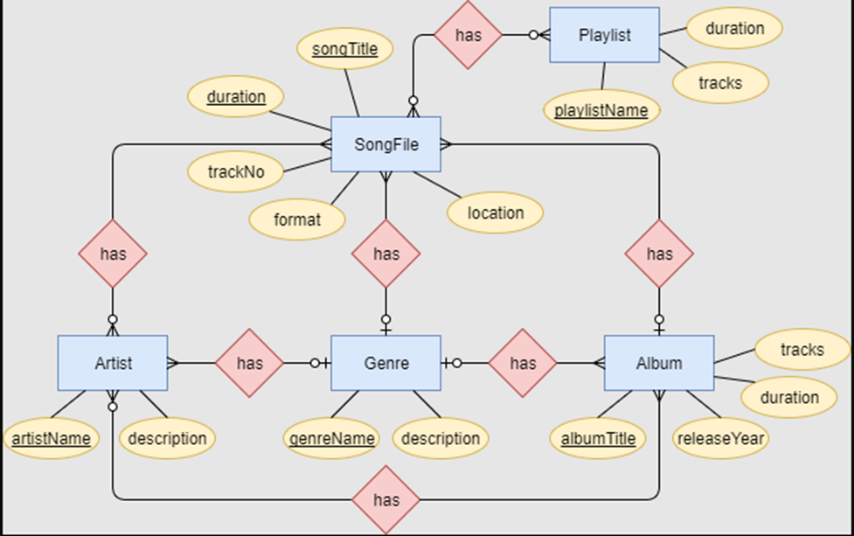

**Figure 5.1 E-R Diagram**

## Block Diagram:

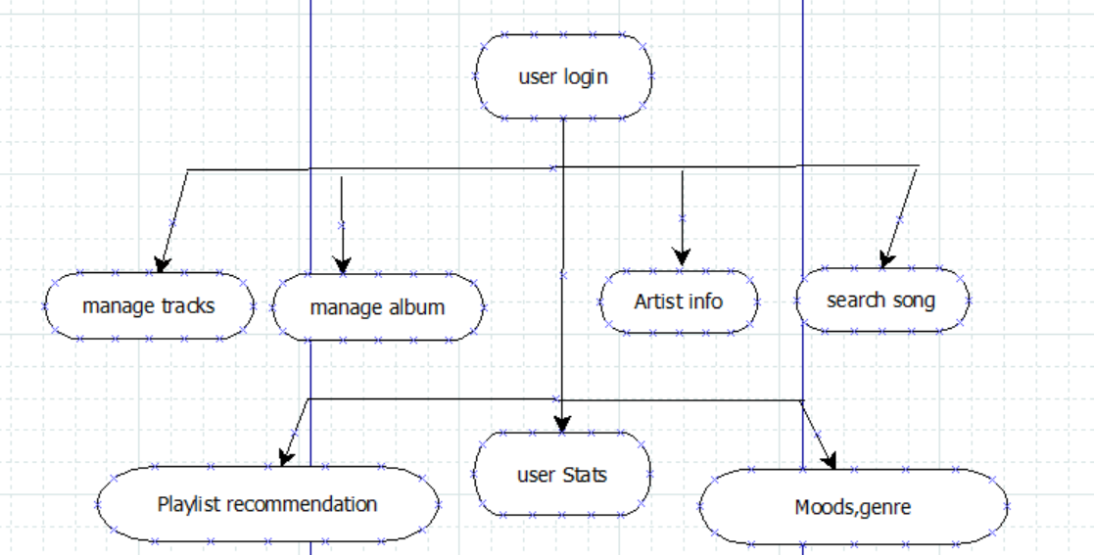

**Figure 5.2 Block Diagram**

## System Architecture:

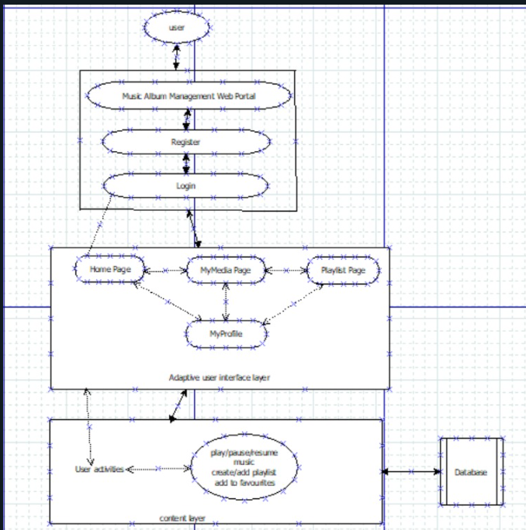

**Figure 5.3 System Architecture**

**Chapter 6**

# 

# Technical specification

The Technical Specifications for the development of Music Album Management System. This system will be developed using HTML,CSS for the user interface, Python, and its Flask framework for the backend. The data communicates with the database server.

1. **Client Application**:

Developed in HTML, CSS for the graphical user interface. Implements the various functionalities required for MAMS.

1. **Database Server:**

SQLite database will be used for data storage. SQLite is often the preferred choice when using Python's Flask framework due to its lightweight and serverless nature. Unlike traditional database management systems, SQLite does not require a separate server process to operate, making it convenient for development purposes. Since SQLite databases are embedded within the application, developers can easily manage and manipulate them without the need for external dependencies or complex setup procedures. This simplicity and ease of use make SQLite ideal for small-scale projects and rapid prototyping, where quick iteration and experimentation are key.

1. **Technology Stack Programming Language:**

Python is often preferred for web development, particularly with frameworks like Flask, due to several compelling reasons. Firstly, Python's simplicity and readability contribute to its widespread adoption. Additionally, Python's rich ecosystem of libraries and frameworks enhances its appeal for web development. Frameworks like Flask provide a solid foundation for building web applications.

1. **User Interface:**

HTML,CSS will be employed to create a rich, platform-independent user interface.

**Chapter 7**

**Project Scheduling Template**

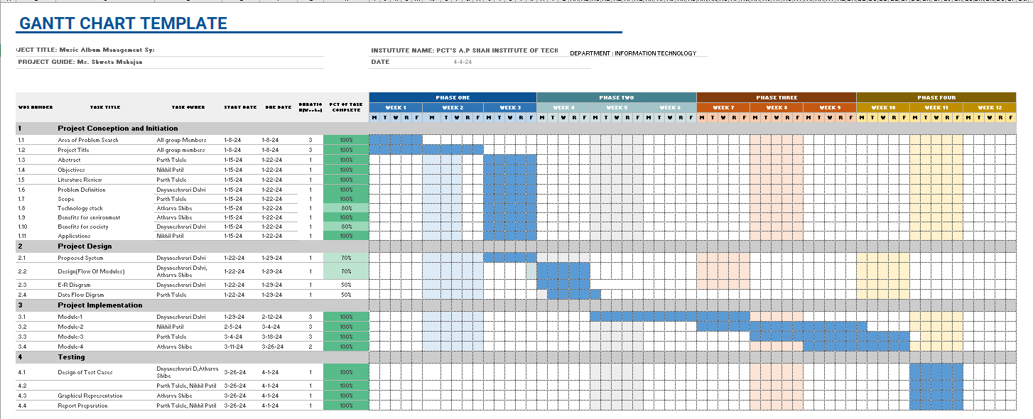

**Figure 7.1 Project Scheduling.**

**Chapter 8**

# Implementation

The implementation phase of the Music Album Management System (MAMS) involved the development of the application using HTML for structuring the web pages, CSS for styling, and the Flask framework for backend development. The implementation process followed a structured approach, encompassing the following steps:

1. **Development Environment Setup:**

HTML, CSS, and the Flask framework were installed on the development machines. A virtual environment was created to manage project dependencies, ensuring a clean and isolated development environment.

1. **Frontend Development with HTML and CSS:**

HTML templates were created for different pages of the application, including login, dashboard, album management, and analytics. CSS stylesheets were utilized to style the HTML templates, ensuring a visually appealing and consistent user interface across all pages.

1. **Backend Development with Flask:**

Flask routes and views were defined to handle HTTP requests and render HTML templates. Backend logic was implemented using Python within Flask routes to interact with the database and perform CRUD operations.

1. **Database Integration with Flask-SQLAlchemy:**

Flask-SQLAlchemy extension was used to integrate the SQLite database with the Flask application. Database models were defined using SQLAlchemy ORM to represent album data, user information, and system configuration.

**Chapter 9**

**Result**

During the development and implementation of the Music Album Management System (MAMS) using Python, flask, HTML & CSS several key outcomes and considerations emerged:

1. **Functionality Achieved:**

The MAMS (Music Album Management System) application has achieved significant milestones, successfully implementing its core functionalities. These functionalities encompass album management, user authentication, and seamless integration with a robust database system. One of the key features of MAMS is its intuitive interface, designed to facilitate efficient management of music albums. Users can easily navigate through the application to add, edit, delete, and view albums, enhancing their overall experience and productivity. Overall, the successful implementation of core functionalities within the MAMS application underscores its commitment to providing users with a reliable and user-friendly platform for managing their music collections.

1. **User Experience and Interface Design:**

The user interface (UI) design, implemented with HTML and CSS, offers a visually appealing and intuitive experience for users. Navigation within the application is straightforward, with clearly labelled buttons and menus facilitating ease of use. The use of CSS stylesheets ensures consistency and coherence across all pages of the application, contributing to a seamless user experience.

1. **Backend Performance and Database Integration:**

Flask's lightweight and modular architecture allowed for efficient backend development, ensuring smooth handling of HTTP requests and responses. Integration with SQLite using Flask-SQLAlchemy facilitated seamless interaction with the database, enabling CRUD operations on album data with minimal latency.

Hence, the development and implementation of the Music Album Management System using HTML, CSS, and Flask have yielded a functional and user-friendly platform for managing music albums. While the current version meets its core objectives, ongoing refinement and enhancement are necessary to ensure that MAMS remains relevant and effective in the dynamic landscape of the music industry.

1. Top of Form

**Chapte****r 10**

# Conclusion

The development and implementation of the Music Album Management System (MAMS) using Python, HTML, CSS, and Flask have resulted in a robust and user-friendly platform for managing music albums. Throughout the project lifecycle, key objectives were successfully achieved, including the creation of an intuitive user interface, seamless integration with the SQLite database, and implementation of essential functionalities such as album management and user authentication. The application's architecture, based on Flask and SQLite, ensures scalability, reliability, and performance, while deployment on a web server using WSGI facilitates accessibility and availability for users.

In conclusion, the development and implementation of the Music Album Management System using HTML, CSS, and Flask have yielded a functional and user-friendly platform for managing music albums. While the current version meets its core objectives, ongoing refinement and enhancement are necessary to ensure that MAMS remains relevant and effective in the dynamic landscape of the music industry.

1. Top of Form

**Chapter 11**

**Future Scope**

While the current version of MAMS meets its core requirements, there are several avenues for future enhancements and expansions:

**1. Integration with External APIs**: Explore integration with external APIs of digital platforms and streaming services for advanced album distribution, enabling users to reach a wider audience and maximize album exposure.

**2. Enhanced Recommendation Algorithms**:

Implement more sophisticated recommendation algorithms to provide personalized album suggestions based on user preferences and browsing history, enhancing the discovery and exploration of new music.

**3. Analytics and Insights**:

Enhance analytics functionalities to provide artists and record labels with deeper insights into album performance metrics, including sales, streaming statistics, and user engagement, enabling informed decision-making and strategic planning.

**4. Optimization and Performance Improvement**:

Continuously optimize the application's frontend and backend codebase to improve performance, efficiency, and user experience, ensuring smooth navigation and responsiveness across different devices and screen sizes.

**References**

##### Building a CRUD Application with Flask and SQLAlchemy: This tutorial covers the basics of building a CRUD (Create, Read, Update, Delete) application using Flask and SQLAlchemy, which could serve as a good foundation for a music album management system.

##### Article link: <https://www.digitalocean.com/community/tutorials/build-a-crud-web-app-with-python-and-flask-part-one>

##### Creating a Music Library Management System with Flask and Vue.js: This article combines Flask with Vue.js for frontend development, providing a comprehensive guide for building a music library management system.

##### Article link: <https://auth0.com/blog/developing-a-modern-web-application-with-python-and-vuejs/>

##### <https://www.researchgate.net/publication/280154217_Efficient_Way_Of_Web_Development_Using_Python_And_Flask>

##### Chauhan, N., Singh, M., Verma, A., Parasher, A., & Budhiraja, G. (2019). Implementation of database using python flask framework: college database management system. International Journal of Engineering and Computer Science, 8(12), 24894–24899. <https://doi.org/10.18535/ijecs/v8i12.4390>